BRAZEN HEAD

**PROJECT SYNOPSIS**

OF MINOR PROJECT

**BACHELOR OF TECHNOLOGY**

**Computer Science and Engineering (Data Science)**

**Fourth Semester**

SUBMITTED BY

**ANSH MITAL ALPA TIWARI**

**Roll Number: 2201331540041 Roll Number: 2201331540027**



**NOIDA INSTITUTE OF ENGINEERING & TECHNOLOGY,**

**GRATER NOIDA, UTTAR PRADESH**

**STUDENT’S DECLARATION**

I hereby certify that the work which is being presented in the minor project report entitled “BRAZEN HEAD”, in fulfillment of the requirement for the award of the Degree of Bachelor of Technology in Department of Computer Science and Engineering (Data Science) of Noida Institute of Engineering and Technology, Greater Noida, A.P.J. Abdul Kalam Technical University, Lucknow, Uttar Pradesh is an authentic record of my own work carried out during Fourth semester.

Date: 21st March, 2024 Name and Signature of student

The major project viva-voce examination of Mr. ANSH MITTAL and Ms. ALPA TIWARI Roll No. 2201331540041 and 2201331540027 Of B.TECH ( CSE(DATA SCIENCE) has been held on __________.

Signature of:

Project Guide: _______ Head of Dept:

(Stamp of organization)

External Examiner: _______ Internal Examiner _________

**ACKNOWLEDGEMENT**

We are highly grateful to the Dr. Dr. Vinod M Kapse, Director, **Noida Institute of Engineering and Technology**, Greater Noida, for providing this opportunity.

The constant guidance and encouragement received from Mr.SOVERSSINGH ,(Deputy HOD ) NIET, Greater Noida, has been of great help in carrying out the project work and is acknowledged with reverential thanks.

We would like to express a deep sense of gratitude and thanks profusely to our project guide, without the wise counsel and able guidance, it would have been impossible to complete the report in this manner.

We express gratitude to other faculty member, Ms. Sonia Arora, for her intellectual support throughout the course of this work.

Finally, the authors are indebted to all whosoever have contributed in this report work.

**ANSH MITTAL**

**&**

**ALPA TIWARI**

**Chapter 1- Introduction**

1.1 Objective

1.2 Problem definition

1.3 Scope

1.4 Definitions, Acronyms and Abbreviations

1.5 Technologies to be used

**Chapter 2- Software Requirement Specifications**

2.1 Introduction

2.1.1 Purpose

2.1.2 Project Scope

2.2 Overall Description

2.2.1 Product/Project Perspective

2.2.2 Product/Project Function

2.2.3 User Classes and Characteristics

2.2.4 Operating Environment

2.2.5 Architecture Design

2.2.6 Constraints

2.2.7 Use Case Model Description

2.2.8 Assumptions and Dependencies

2.3 System Features

2.4 External Interface Requirements

2.4.1 User Interfaces

2.4.2 Hardware Interfaces

2.4.3 Software Interfaces

2.4.4 Communications Interfaces

2.5 Other Nonfunctional Requirements

2.5.1 Performance Requirements

2.5.2 Safety Requirements

2.5.3 Security Requirements

2.5.4 Software Quality Attributes

**Chapter 3- System Design (use any)**

3.1 Flowcharts

3.2 ER Diagram

3.3 Design Methodology

3.4 Software Development Model

3.5 Databse Design

3.5.1 ER Diagram

3.5.2 Schema

3.6 DFD’s

3.7 Activity Diagram

3.8 Class Diagram

3.8.1 Sequence Diagrams

**Chapter 4- System Implementation** (not req for synopsis)

4.1 Coding

4.2 Testing

4.3 Snapshots

**Chapter 5- Conclusions and future scope**

5.1 Conclusion

5.2 Future Scope

**Chapter 6- References**

6.1 Books

6.2 URLs

**Chapter 1- Introduction**

In the early 13th century, the princesses of the Holy Roman Church elected Pope Sylvester II as the Pope of the Catholic World. Powered with skills, intellect and a mindset to change the world for the better with the weapons of science and technology.

In this very spirit, he and his disciples travelled all the way to India, an ocean of vast ancient and mystical knowledge, to gain expertise and equipped with it, he created such a mechanical model that had the capability to answer any of the questions put into it in a yes or a no. And this really worked for all the questions. But like every other sad story, the fate of this mechanical model is unknown and still people believe that this model survives this day and is kept tucked away in the Vatican Archives.

In order to draw light upon the lost auras still between us for a thousand of years, we present you our Brazen Head, our very AI model, modeled upon the vision of Pope Sylvester II. This model has the capability to answer every question put into it in the least possible words and aims to answer from the historical point of view, what and where went wrong.

* 1. **Objective**

To engage in multi-turn conversations, remembering previous interactions and providing relevant follow-up responses.

* 1. Problem definition

A legendary automaton in the early modern period whose ownership was ascribed to late medieval scholars. This chatbot, originally credited as witchcraft and magical, aims not only to answer as its original response of "yes" and "no", but also believes in answering in around 90 characters of text.

* 1. Scope

The scope of the Brazen Head system includes leveraging AI and NLP to provide users with personalized responses and engaging conversations. It encompasses user authentication, secure communication, and integration with external services while ensuring compliance with data privacy regulations and continuous improvement through user feedback.

1.4 Definitions, Acronyms and Abbreviations

* **BH:** Brazen Head - Refers to the name of the system, inspired by the legendary automaton.
* **NLP:** Natural Language Processing - Technology enabling the system to understand and interpret human language.
* **AI:** Artificial Intelligence - Powers the system's ability to generate intelligent responses and adapt to user interactions.
* **UI:** User Interface - The visual and interactive components through which users interact with the Brazen Head system.
* **DFD:** Data Flow Diagram - Illustrates the flow of data and processes within the Brazen Head system.
* **ER Diagram:** Entity-Relationship Diagram - Represents the database schema and relationships between entities within the Brazen Head system.
* **HTTPS:** Hypertext Transfer Protocol Secure - Ensures secure communication between the Brazen Head system and users' devices.
* **GDPR:** General Data Protection Regulation - European Union regulation governing the protection of personal data and privacy.
* **RBAC:** Role-Based Access Control - Security model restricting system access based on user roles and permissions.
* **MFA:** Multi-Factor Authentication - Authentication method requiring multiple forms of verification to access the Brazen Head syste

**1.5 Technologies to be used**

* React.js: A JavaScript library for building user interfaces.
* CSS Modules: A CSS file format that allows for local scoping of CSS styles in React components.
* OpenAI API: The OpenAI API is used for natural language processing and generating AI-powered responses.
* Node.js: A JavaScript runtime environment that allows running JavaScript on the server-side.
* Express: A web application framework for Node.js used to handle backend API routes and requests.
* React Router: A library for handling routing in a React application.
* Axios: A promise-based HTTP client for making API requests from the frontend.
* Firebase: A comprehensive development platform that provides authentication, hosting, and database services.
* dotenv: A zero-dependency module for loading environment variables from a .env file.
* CORS: Cross-Origin Resource Sharing, a mechanism for handling cross-origin requests in web browsers.
* Nodemon: A development tool that automatically restarts the server when changes are made to the code.

**Chapter 2- Software Requirement Specifications**

**2.1 Introduction**

Before getting started, make sure you have the following prerequisites installed:

* + Node.js: Install Node.js from the official website.
  + OpenAI API key: Sign up for the OpenAI API and obtain an API key.
  + Firebase account: Create a Firebase account and set up a new project.

**2.1.1 Purpose**

The purpose of the Brazen Head system is to provide users with an intelligent and interactive platform for seeking information, engaging in conversations, and receiving personalized responses. Rooted in the concept of a legendary automaton, the Brazen Head aims to emulate the experience of conversing with a knowledgeable entity capable of providing insightful answers to user queries. Whether users seek factual information, guidance, or simply engaging conversation, the Brazen Head endeavors to deliver contextually relevant and helpful responses. By leveraging natural language processing and artificial intelligence technologies, the system aims to understand user inputs, process them effectively, and generate appropriate and meaningful responses. Ultimately, the purpose of the Brazen Head system is to enrich user experiences, foster learning and exploration, and provide a valuable resource for information and interaction.

**2.1.2 Project Scope**

The scope of the Brazen Head encompasses the design, development, and deployment of a software platform that delivers tailored AI responses to individuals based on their unique prompts and preferences. The system will leverage advanced technologies, such as machine learning algorithms, data analytics, and natural language processing techniques, to analyze diverse sources of healthcare data and generate personalized recommendations and solve queries.

**2.2 Overall Description**

Brazen Head is a cutting-edge tool powered by OpenAI, designed to elevate chatbots to unprecedented levels of sophistication and intelligence. This advanced platform enables chatbots to engage in dynamic, multi-turn conversations, where they can remember previous interactions and provide contextually relevant follow-up responses. By leveraging state-of-the-art artificial intelligence, Brazen Head ensures that each interaction feels more natural and intuitive, allowing users to experience a seamless and engaging conversational flow. Whether for customer service, virtual assistance, or personal companionship, Brazen Head represents a significant advancement in the capabilities of conversational AI technology. It can handle complex queries, understand nuanced language, and adapt to the unique needs of each user, making it an invaluable tool for businesses and individuals alike. With Brazen Head, the future of interactive, intelligent communication is here.

2.2.1 Product/Project Perspective

The Brazen Head chatbot project leverages cutting-edge AI technology to revolutionize user interactions, offering a sophisticated and intelligent conversational platform. It integrates real-time chat capabilities with advanced AI-powered responses, ensuring a seamless and engaging user experience. The project's perspective encompasses the vision, context, and user needs that drive its development.

2.2.2 Product/Project Function

* Immediate Response: Users expect real-time answers to their queries, which the Brazen Head chatbot delivers through its real-time chat interface.
* Contextual Relevance: The chatbot uses the OpenAI API to provide intelligent, contextually appropriate responses, ensuring conversations remain relevant and useful.
* Natural Interaction: By supporting natural and interactive dialogues, the chatbot meets the user demand for human-like interactions with digital platforms.
* Personalization: Users seek personalized experiences, which the chatbot offers through secure authentication, allowing for tailored conversations based on previous interactions.
* User Feedback: Direct communication channels via feedback and query forms enable users to influence the chatbot's development, ensuring it continuously meets their evolving needs.
* Secure Data Handling: Integration with Firebase for authentication and data storage ensures user data is managed securely and efficiently, addressing privacy and security concerns.

**2.2.3 User Classes and Characteristics**

The Brazen Head chatbot serves diverse user classes, each with unique needs. End users, including the general public, customers, and learners, seek instant, relevant responses and natural interactions. Business users, such as customer support and marketing teams, require efficient customer handling and data collection features. Administrators focus on seamless integration, security, and content management, while developers need robust APIs and tools for customization. Stakeholders, including executives and investors, look for performance insights and ROI evidence. By catering to these varied user classes, Brazen Head ensures a user-centric experience, enhancing satisfaction, operational efficiency, and business outcomes.

**2.2.4 Operating Environment**

The Brazen Head chatbot operates within a sophisticated and secure digital environment, leveraging a cloud-based infrastructure for high availability and scalability. It integrates with the OpenAI API to provide intelligent, contextually relevant responses, ensuring state-of-the-art AI interactions. The chatbot features a responsive, clean UI adaptable to various devices, enhancing user experience across desktops, tablets, and smartphones. Firebase integration facilitates secure authentication, personalized conversations, and efficient data management. Robust security measures, including encryption and compliance with data protection regulations, safeguard user privacy. Continuous development, testing, and deployment ensure the chatbot remains up-to-date with new features and improvements. Real-time monitoring and analytics provide insights into performance and user behavior, enabling proactive management. Additionally, support for multiple languages allows the chatbot to cater to a global audience. This comprehensive operating environment ensures the Brazen Head chatbot delivers a reliable, secure, and user-friendly experience, meeting diverse user needs and adapting to technological advancements.

**2.2.5 Architecture Design**

The architecture design of the Brazen Head chatbot is a multi-tiered system that ensures scalability, reliability, and security. At the core, it integrates with the OpenAI API, leveraging powerful AI and machine learning models for generating intelligent responses. The frontend consists of a responsive, clean user interface built with modern web technologies, ensuring compatibility across various devices. The backend is hosted on a cloud platform, providing robust infrastructure for handling dynamic loads and ensuring high availability. Firebase is utilized for user authentication, real-time database services, and secure data storage, enhancing the personalization and security aspects. The architecture also includes API gateways for seamless integration with third-party services and business systems. Continuous monitoring and analytics are embedded into the design to track performance and user interactions, allowing for real-time insights and proactive maintenance. This layered architecture ensures that the Brazen Head chatbot is efficient, secure, and capable of delivering a superior user experience.

**2.2.6 Constraints**

The Brazen Head chatbot operates under several constraints that impact its design and functionality. One primary constraint is the dependency on the OpenAI API, which requires a stable internet connection and adherence to usage limits and API call costs. Additionally, the need for robust security measures, such as encryption and compliance with data protection regulations like GDPR and CCPA, imposes strict requirements on data handling and storage practices. The system's reliance on cloud infrastructure introduces potential constraints related to service availability and scalability, which must be managed to avoid downtime. Integration with Firebase for authentication and data storage, while providing significant benefits, also necessitates careful handling of user data to maintain privacy and security. Furthermore, the requirement to support multiple languages adds complexity to the development and maintenance processes, ensuring accurate and efficient localization. These constraints collectively shape the architecture and operational strategies of the Brazen Head chatbot, ensuring it meets user expectations while maintaining compliance and performance standards.

**2.2.7 Use Case Model Description**

The use case model describes the functionality and interactions within the chatbot system. Users have the ability to register for an account, providing necessary information for personalized conversations, and subsequently log in securely through Firebase integration. Once logged in, users can engage in real-time conversations with the chatbot, which generates contextually relevant responses using the OpenAI API, ensuring an interactive and informative experience. Additionally, users can submit feedback, questions, or queries through a contact form, facilitating direct communication with administrators for further assistance or improvements. Each use case, from user authentication to real-time chat and feedback submission, contributes to the overall goal of providing a responsive, intelligent, and user-friendly interface that adapts to different screen sizes and enhances the user experience.

**2.2.8 Assumptions and Dependencies**

Assumptions and dependencies play crucial roles in shaping the functionality and performance of the chatbot system. Assumptions involve expectations about user behavior, system capabilities, or external factors, which guide the design and implementation process. For instance, assumptions may include user proficiency in interacting with the chatbot interface or the availability of a stable internet connection for real-time communication. Dependencies, on the other hand, represent the reliance of certain features or components on external services, libraries, or infrastructure. In the context of the chatbot system, dependencies may encompass the integration with third-party APIs like the OpenAI API for response generation or Firebase for authentication and database management. Recognizing and addressing these assumptions and dependencies are essential for ensuring the robustness, reliability, and scalability of the chatbot system, ultimately enhancing the user experience and functionality.

**2.3 System Features**

The chatbot system incorporates essential features to facilitate seamless user interaction and efficient functionality. Users can securely register and log in through Firebase integration, ensuring authentication and personalized experiences. Once logged in, users engage in real-time conversations with the chatbot, which generates contextually relevant responses using the OpenAI API. These responses are designed to be concise, around 90 characters, enabling quick and efficient communication. The chatbot's user interface is responsive, adapting smoothly to different screen sizes for a visually appealing and clutter-free experience. Additionally, users can provide feedback, ask questions, or submit queries through a contact form, fostering direct communication with administrators for assistance or improvements. These features collectively enhance the chatbot's usability, effectiveness, and user satisfaction.

**2.4 External Interface Requirements**

External Interface Requirements for the chatbot system encompass various interactions and integrations with external entities to ensure seamless functionality and user experience. These requirements include interfacing with Firebase for user authentication and database management, enabling secure user registration and login processes. Additionally, integration with the OpenAI API is essential for generating contextually relevant responses during real-time conversations with users. The chatbot's interface must also be compatible with different devices and screen sizes, necessitating responsive design principles for optimal user accessibility. Furthermore, the system should facilitate communication with administrators through a contact form, allowing users to submit feedback, queries, or requests for assistance. By meeting these external interface requirements effectively, the chatbot system can deliver a robust, user-friendly experience that meets the needs and expectations of its users.

2.4.1 User Interfaces

User interfaces (UI) in the chatbot system serve as the primary point of interaction between users and the system. These interfaces encompass both the visual elements and interactive components through which users communicate with the chatbot. Key aspects of the UI include a clean and intuitive design that adapts to various screen sizes for optimal usability. Users can access the chatbot through a web-based interface or mobile application, where they can engage in real-time conversations and receive instant responses. The UI should prioritize responsiveness, ensuring smooth navigation and readability across different devices. Additionally, interfaces for user registration, login, and feedback submission should be user-friendly and secure, enhancing the overall user experience. Through effective UI design, the chatbot system aims to provide a seamless and engaging interaction for its users.

**2.4.2 Hardware Interfaces**

In the context of a chatbot system, hardware interfaces refer to the physical devices or components through which users access the system. Primarily, this involves devices such as computers, smartphones, tablets, or any other internet-enabled devices capable of running the chatbot application or accessing its web interface. These devices serve as the hardware interface between the user and the chatbot system. Additionally, peripherals such as keyboards, mice, touchscreens, and microphones may also be considered hardware interfaces, enabling users to input queries or interact with the chatbot in various ways. The chatbot system should be designed to be compatible with a wide range of hardware interfaces to ensure accessibility and usability for users across different devices and platforms.

**2.4.3 Software Interfaces**

Software interfaces in the context of a chatbot system refer to the mechanisms through which different software components interact and communicate with each other. In the case of a chatbot, these interfaces include APIs (Application Programming Interfaces) used to integrate external services or libraries into the system. For instance, the chatbot may utilize the OpenAI API for generating responses or Firebase API for user authentication and data storage. These software interfaces enable seamless communication between the chatbot application and external services, allowing for the exchange of data and functionalities. Additionally, within the chatbot application itself, there are software interfaces between different modules or components responsible for handling user input, processing requests, generating responses, and managing user data. Effective design and implementation of software interfaces are essential for ensuring interoperability, scalability, and maintainability of the chatbot system.

**2.4.4 Communications Interfaces**

Communication interfaces in a chatbot system facilitate the exchange of information between different entities, including users, the chatbot application, and external services. These interfaces encompass protocols, standards, and mechanisms used for transmitting data and messages. For instance, HTTP (Hypertext Transfer Protocol) is commonly used for communication between the user's device and the chatbot server, enabling the transfer of user queries and receiving chatbot responses. WebSocket protocols may also be employed to establish persistent, bi-directional communication channels for real-time interactions. Additionally, communication interfaces enable integration with third-party APIs, such as the OpenAI API for natural language processing or Firebase API for authentication and data storage. Effective communication interfaces are essential for ensuring seamless interaction, responsiveness, and interoperability within the chatbot system.

**2.5 Other Nonfunctional Requirements**

**2.5.1 Performance Requirements**

Performance requirements for the Brazen Head system are critical to ensure optimal functionality and user satisfaction. The system must deliver near-instantaneous responses to user inquiries, maintain scalability to handle varying levels of traffic without performance degradation, and efficiently utilize system resources to minimize operational costs. Concurrent user support, accuracy in responses, high availability, and robust security measures are also paramount. Meeting these requirements guarantees a seamless and engaging user experience, fostering user trust and satisfaction with the Brazen Head system. Regular monitoring, testing, and optimization are essential to uphold performance standards and adapt to evolving user needs and technological advancements.

**2.5.2 Safety Requirements**

Safety requirements for the Brazen Head system are paramount to ensure user well-being and prevent potential harm. These requirements encompass several key aspects, including data privacy and security measures to protect users' personal information, robust content filtering and moderation mechanisms to prevent the dissemination of inappropriate content, and clear user safety guidelines to educate users on respectful behavior and reporting procedures. Additionally, the system should have protocols in place for emergency situations and enforce age restrictions with parental controls to ensure age-appropriate experiences. By adhering to these safety requirements, the Brazen Head system can foster a secure and supportive environment for users, promoting trust, well-being, and positive engagement within the community while mitigating potential risks or hazards. Regular monitoring, updates, and user education initiatives are essential to uphold safety standards and address emerging threats effectively.

**2.5.3 Security Requirements**

Security requirements for the Brazen Head system are fundamental to ensuring the confidentiality, integrity, and availability of user data and system resources. Critical measures include encrypting sensitive user information both in transit and at rest, implementing strong authentication mechanisms like multi-factor authentication and secure password policies, and enforcing secure communication protocols to prevent data interception. Input validation techniques are essential to thwart common vulnerabilities such as injection attacks, while robust session management practices safeguard against session hijacking. Compliance with data privacy regulations ensures that user data is handled responsibly and transparently. Comprehensive logging and auditing capabilities enable the monitoring of system activities, facilitating early detection and response to security incidents. Additionally, the presence of an incident response plan outlines procedures for effectively managing and mitigating security breaches. By adhering to these security requirements, the Brazen Head system can instill confidence in users and maintain the trustworthiness of the platform. Regular security assessments and updates are imperative to adapt to evolving threats and ensure ongoing protection of user information.

**2.5.4 Software Quality Attributes**

Software quality attributes for the Brazen Head system include reliability, usability, performance, security, maintainability, and scalability. Reliability ensures consistent performance without errors, usability focuses on an intuitive interface for easy interaction, and performance ensures quick responses even during high traffic. Security measures protect user data, while maintainability allows for efficient updates and fixes. Scalability ensures the system can handle growing demands. These attributes collectively contribute to a high-quality user experience and system success.

**Chapter 3- System Design**

**3.1 Flowcharts**

st=>start: Start

op1=>operation: User Interaction

cond1=>condition: Query Received?

op2=>operation: Generate Response

cond2=>condition: Error Detected?

op3=>operation: Handle Error

op4=>operation: Deliver Response

e=>end: End

st->op1->cond1

cond1(yes)->op2

cond1(no)->e

op2->cond2

cond2(yes)->op3

cond2(no)->op4

op3->op4

**3.2 ER Diagram**

erDiagram

User {

UserID (PK)

Username

Email

Password

RegistrationDate

LastLoginTimestamp

ProfilePicture

}

Conversation {

ConversationID (PK)

UserID (FK)

Timestamp

QueryText

ResponseText

}

Feedback {

FeedbackID (PK)

UserID (FK)

Timestamp

FeedbackText

}

Interaction {

InteractionID (PK)

UserID (FK)

Timestamp

InteractionType

}

SystemConfiguration {

ConfigurationID (PK)

ConfigurationKey

ConfigurationValue

}

User --|> Conversation

User --|> Feedback

**3.3 Design Methodology**

The design methodology for the Brazen Head system adopts a user-centered and iterative approach to ensure the system's effectiveness and usability. Beginning with thorough requirement analysis, the design process focuses on understanding user needs, business objectives, and technical constraints. Iterative design methodologies, such as Agile, allow for continuous feedback and refinement, enabling the design team to adapt to evolving requirements and user feedback. User-centered design principles drive the creation of prototypes and design concepts, which are validated through usability testing and user feedback sessions. Modular design principles facilitate scalability and maintainability, breaking down the system into reusable components. Cross-functional collaboration ensures alignment between design, development, and business stakeholders, fostering shared understanding and collective ownership of design decisions. By following this comprehensive design methodology, the Brazen Head system can be designed to deliver a seamless and engaging user experience while effectively meeting user needs and business objectives.

**3.4 Software Development Model**

The software development model chosen for the Brazen Head system is a critical decision that shapes the project's methodology and outcomes. Among the various options available, the Agile model stands out for its iterative and collaborative approach, making it well-suited for a dynamic project like Brazen Head where requirements may evolve over time. With Agile, the development process is divided into small, manageable iterations known as sprints, allowing for continuous feedback and adaptation to changing needs. This model promotes flexibility, transparency, and customer satisfaction, fostering a collaborative environment where stakeholders actively participate in the development process. By embracing Agile principles, the Brazen Head team can deliver high-quality software that meets user expectations while remaining responsive to evolving market demands.

**3.5 Database Design**

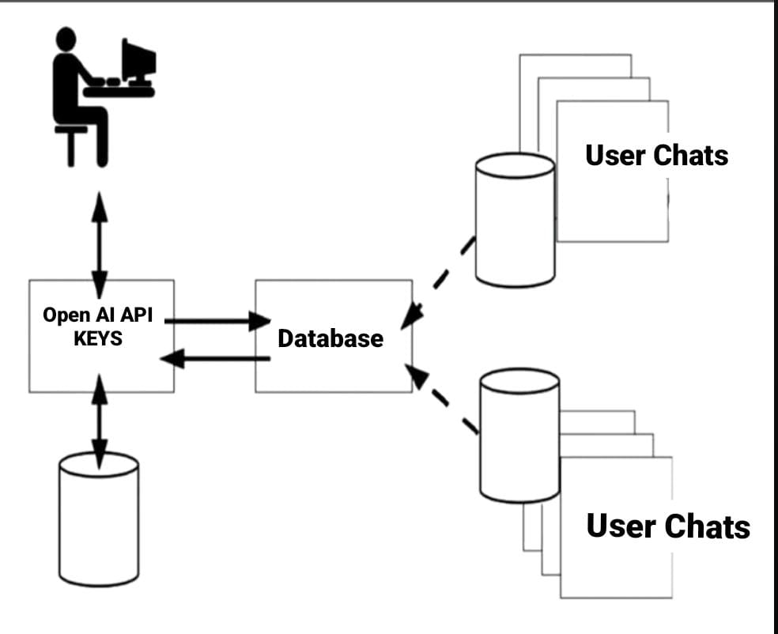

**3.6 DFD’s**

The Data Flow Diagrams (DFDs) for the Brazen Head system offer a visual depiction of how data moves and processes are executed within the system. At the highest level, the Context Diagram provides an overarching view of the system's interactions with external entities like users and external services. Moving to the Level 0 DFD, the system is broken down into major subprocesses or modules, outlining functions such as user input, natural language processing, response generation, and interaction logging. Further detailed DFDs, spanning Level 1 and beyond, delve deeper into these subprocesses, delineating intricate processes like tokenization and semantic analysis within the natural language processing module. The External Entity Diagram clarifies the entities interacting with the system, while the Data Store Diagram elucidates the types of data stored and accessed by the system. Together, these DFDs offer a comprehensive understanding of the Brazen Head system's architecture, aiding in design, analysis, and documentation processes.

**4. System Implementation**

**4.1 Coding:**

Coding Snapshots:

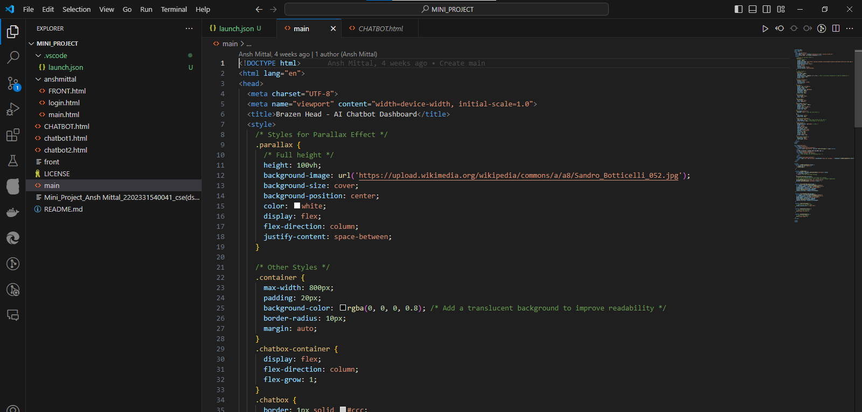

Output Snapshots:

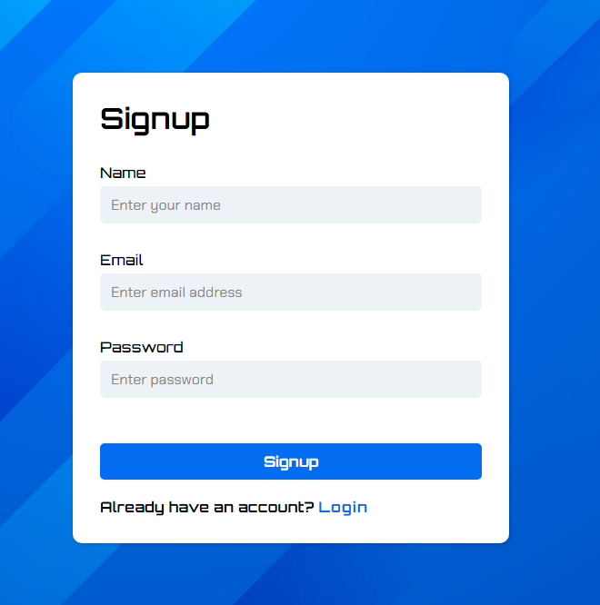

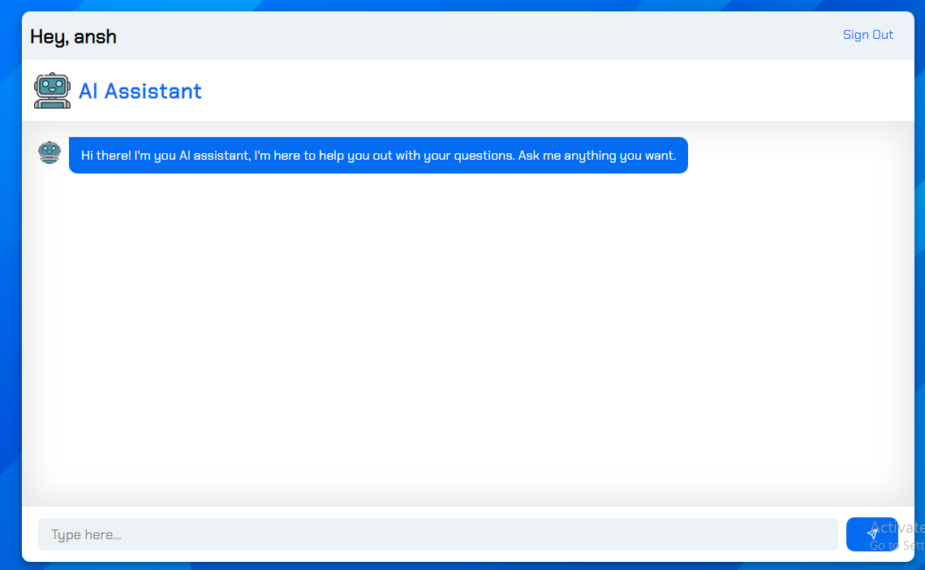

**5. Conclusions and future scope**

**5.1 Conclusion**

In conclusion, the Brazen Head system demonstrates its capability to deliver a reliable, user-friendly, and secure platform for interactive experiences. By prioritizing software quality attributes like reliability, usability, performance, security, maintainability, and scalability, the system can provide users with a high-quality experience that fosters trust and satisfaction. Looking ahead, there are numerous avenues for future development and improvement. These include enhancing natural language understanding, integrating with emerging technologies, implementing personalization features, expanding to new platforms, and continuously iterating to refine performance and user experience. By embracing these opportunities for growth and innovation, the Brazen Head has the potential to evolve into a versatile and indispensable tool for users seeking intelligent and engaging interactions.

**5.2 Future Scope:**

The future scope for the Brazen Head system is expansive, offering avenues for development and growth across various dimensions. Advanced research in natural language processing can enhance the system's ability to comprehend nuanced user queries and contexts, thereby refining response accuracy. Integration with cutting-edge technologies such as machine learning and artificial intelligence holds promise for enabling the system to dynamically adapt and improve through user interactions, fostering personalized and insightful responses. Moreover, expanding accessibility to diverse platforms and languages, coupled with robust localization efforts, can broaden the system's global reach and user engagement. Embracing continuous improvement strategies, including user feedback analysis and iterative enhancements, remains essential for ensuring the system's ongoing relevance and effectiveness in meeting evolving user needs and expectations. By capitalizing on these future opportunities, the Brazen Head system can evolve into a versatile and indispensable tool, delivering intelligent and enriching experiences tailored to each user's unique preferences and requirements.

6. References

* Vatican Archives
* Firebase Documentation
* OpenAI Documentation
* Wikipedia
* IEEE Transactions on Pattern Analysis and Machine Intelligence.
* Stack Overflow
* GitHub Repository for Chatbot Development Framework